StudyCircle — Product Roadmap
Capstone Project Artifact
FOR EXAMPLE PURPOSES ONLY. This roadmap is for a sample project (StudyCircle). Each team should review and assess it for applicability, build its own from its own backlog and velocity, and consider items this example does not include. Examples: client blackout dates or a client-imposed demo date; exam weeks and holidays that cut capacity; lead time for campus IT or hardware purchases; research milestones for R&D projects (literature review done, experiment design approved, data collected, results analyzed); a public showcase or poster deadline; and a maintenance or warranty period after handoff.

StudyCircle ships in three releases over 25 weeks (two semesters) — MVP in week 13 at the end of semester 1, the AI assistant in week 17, and the hardened final release with handoff in week 25. Each release is a gate: the client accepts it at the sprint review before the next phase starts.

At a glance
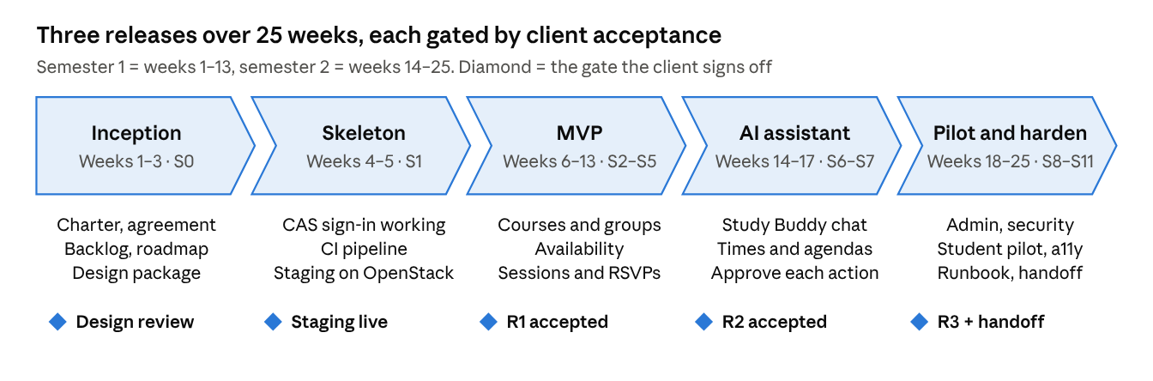
Figure 1 - Roadmap · 5 phases, 5 client gates

The AI assistant is deliberately second: it builds on groups, availability and sessions that must already work and be accepted in week 13.

Schedule
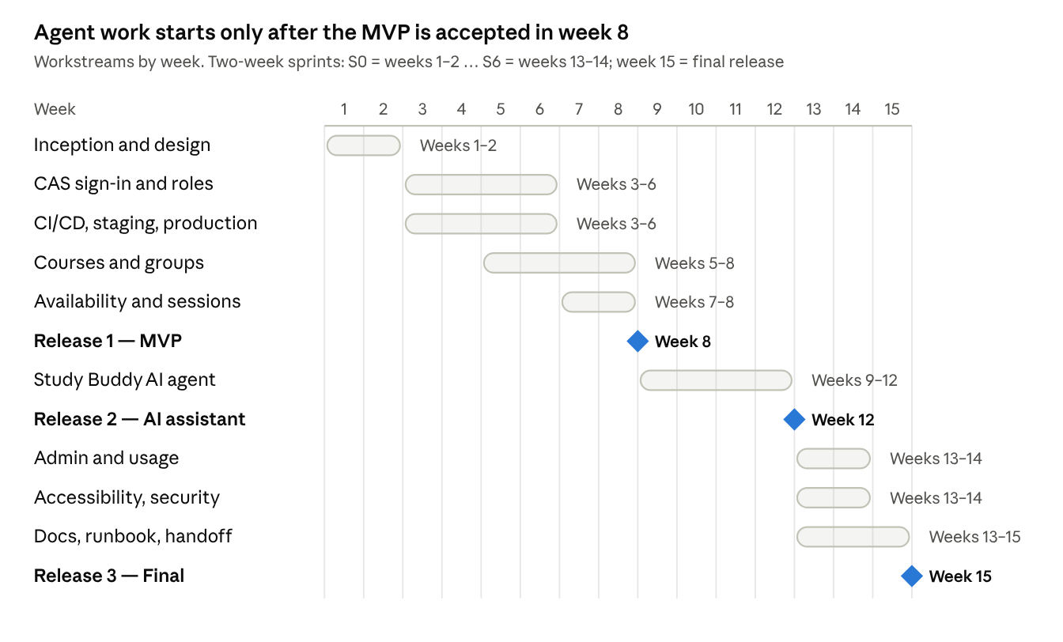
Figure 2: Gantt · workstreams by week, 3 releases
DevOps and CAS run first because every later demo happens on the staging server; the last eight weeks add no new user features, only admin tools, a pilot with real students, hardening and handoff.

Releases
Release | Week | What the client gets | Accepted when
R1 — MVP | 13 (end of semester 1) | CAS sign-in, courses, study groups, availability, sessions and RSVPs on production | Students can find, join and schedule end to end; all R1 "Must" stories meet the Definition of Done
R2 — AI assistant | 17 | Study Buddy chat: recommends groups, proposes times, drafts agendas; every action approved by the user | Approval flow tested; agent spend within the monthly cap
R3 — Final | 25 | Admin console, results of a pilot with real students, accessibility and security hardening, backups, user guide and runbook | Pilot feedback addressed; WCAG 2.1 AA and OWASP checks pass; a non-author redeploys from the runbook
Table 1: Release schedule

Using this roadmap at instructor meetings
- Show the chevron diagram and mark the current phase; this is the executive view.
- Report each upcoming gate as On track, At risk or Late, with one line on why.
- Keep the client's detailed bi-weekly schedule, if they provide one, in GitLab — not on this page.

Key dependencies
- CAS service registration by campus IT — needed for S1 (request in week 1).
- OpenStack project quota, floating IPs and DNS — needed for S1.
- OpenAI API key and monthly spend cap from the client — needed for S6 (week 14).

